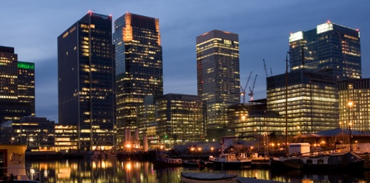
Grey & Associates
Party Wall Surveyors
{{bo_letter_names}}
{{bo_correspond_add_vert}}
{{todays_date}}
Dear {{bo_dear_mrmrs}},

Security for Expenses - The Party Wall etc. Act 1996.

As {{ao_plural}} of {{ao_property_add_horz}} {{ao_i_we2}}, {{ao_notice_names}}, hereby request that a sum of money be put into escrow for use as security for expenses in accordance with Section 12(1) of the Party Wall etc. Act 1996.

{{ao_i_we}} would ask that a sum of monies (to be determined by the surveyors) be put into escrow with a solicitor (or escrow agent) specifically to cover any unforeseen circumstances with regard to the excavations and underpinning works within 3 metres of {{ao_my_our}} building. This sum is not to be used for making good of any damage, and is strictly to be used to complete any required works in order to restore support to {{ao_my_our}} building.

Upon completion of the works required to return support to {{ao_my_our}} building, and settling of the solicitor’s (or escrow agent’s) fees, the full amount held in escrow, plus any interest accrued, is to be released back to you immediately.

Kind regards,
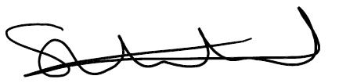
______________________
* Steve Whitehead
Grey & Associates Ltd
T: 020 8150 3762
E: steve.w@greyandassociates.co.uk

“Could saving a few pounds now cost thousands in legal bills later?”

*Authorised to sign on behalf of the {{ao_plural}}

